S_PL0_86000032-FINANCIAL STATEMENTS



This simulation describes how to use T-Code S_PL0_86000032: Financial Statements.

Please note that in S/4 there are several CDS Views available for displays of G/L balances, which are more user friendly and flexible than the S_PL0* reports. It is recommened that you consider using those CDS Views to meet your business needs.

Click to continue to learn details of S_PL0_86000032 report.

Explanation | Screenshot
[1] s_pl0_86000032 is now entered in the Transaction box. | 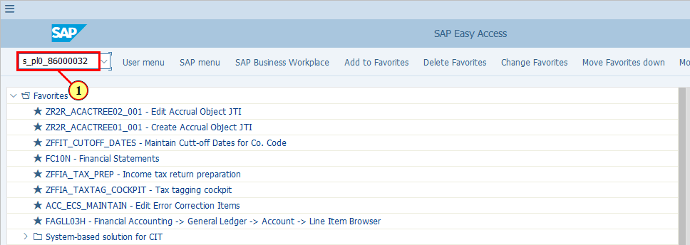
  You may select the G/L accounts that you wish to display using either ranges or single values, but bear in mind that this report is displayed based on Financial Statement Versions (FSV), which will be inputted later on the selection screen. Your selected G/L accounts need to be mapped to your selected FSV in order for its balances to be displayed. | 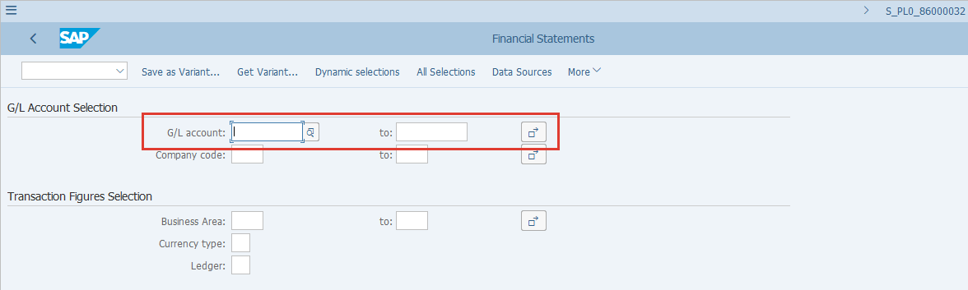
  If you wish to restrict your G/L accounts selection based on certain parameters in the G/L Master record, you may use the Dynamic selections button.  [2] Click Dynamic selections .  You can also press Shift+F4. | 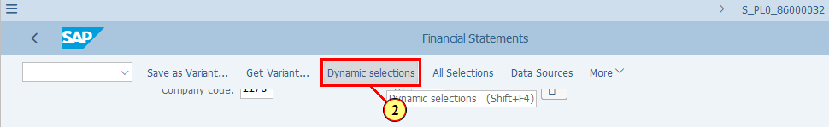
[3] Clicking the 'Close folder' icon closes the folder GL A/C Master Record.  This folder contains G/L Master Record parameters at Chart of Accounts level, i.e. JTIO level. | 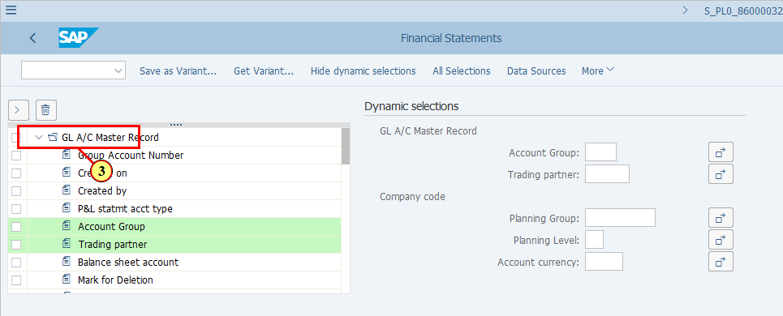
[4] Clicking the 'Close folder' icon closes the folder Company code.  This folder contains G/L Master Record parameters at company code level. | 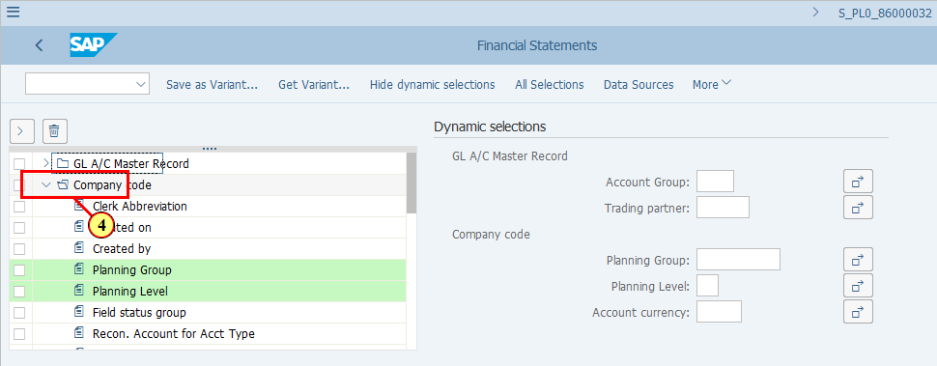
[5] To use a field from this list as a selection criterion, follow the steps demonstrated.  Profit Center is clicked. | 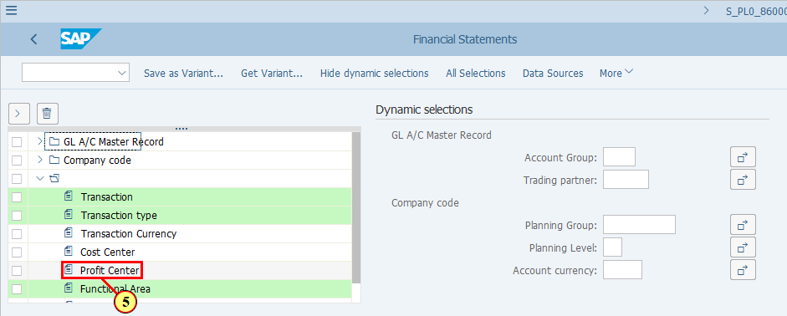
[6] Click TAKE .  Alternatively you can double click on the field to achieve the same. | 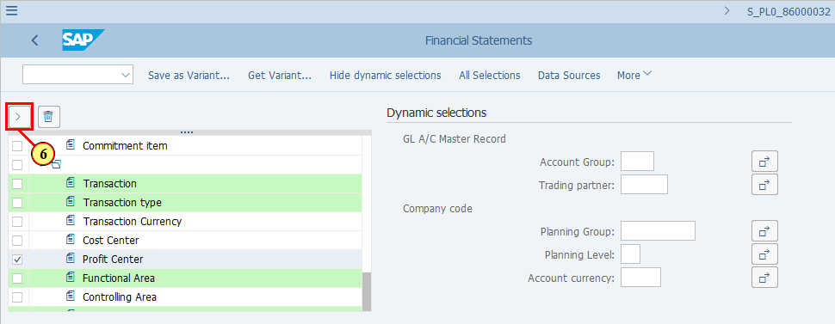
  You should notice that Profit Center has been moved to the right hand side so that you can put your restrictions accordingly.  [7] To move a field back to the list, simply select it and follow the steps demonstrated.  The Profit Center field is selected. | 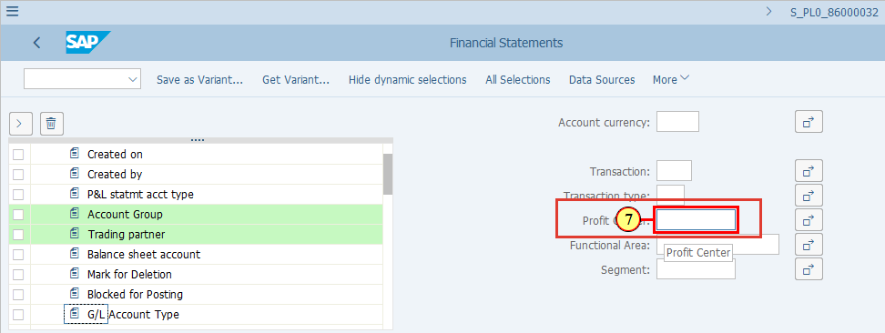
[8] Click REVERT . | 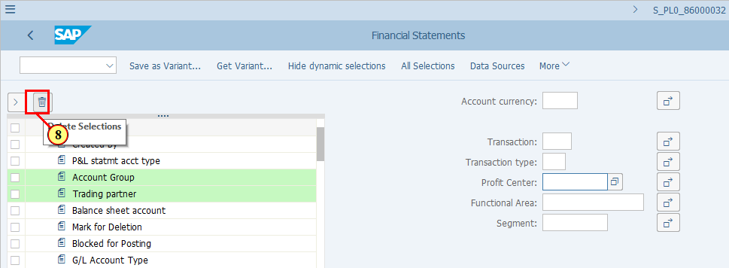
[9] Click Hide dynamic selections .  You can also press Shift+F4. | 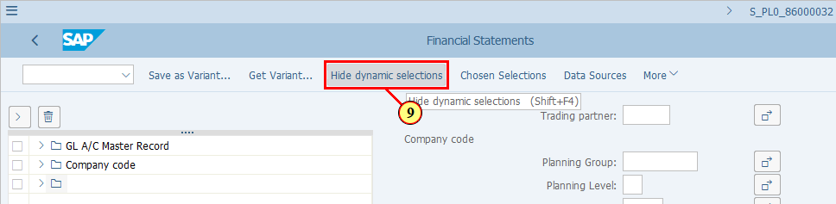
[10] The Company code field is filled out. | 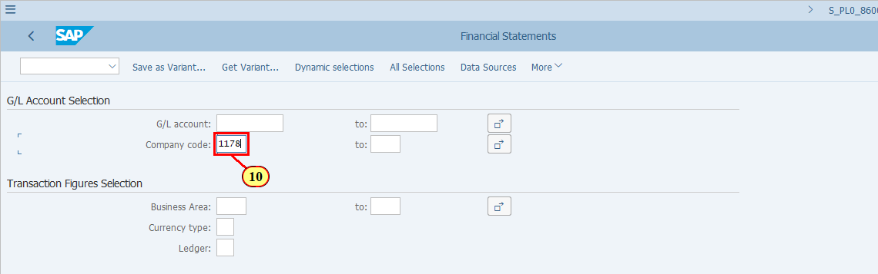
  You can choose a combination of one currency type and one ledger to be used to display your Financial Statement. As you can see these are not mandatory fields, so we can leave them blank and see in which currency type and ledger our Financial Statement is going to be displayed. | 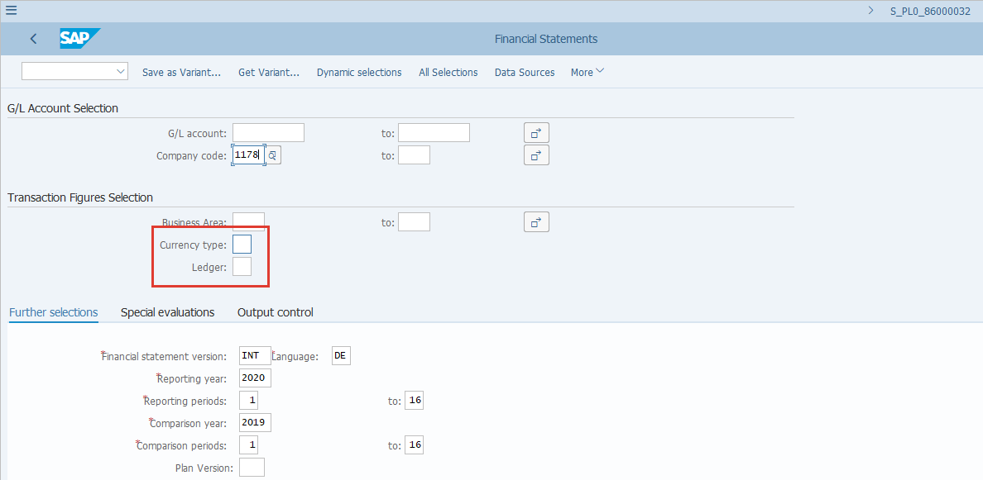
[11] The *Financial statement version field is filled out.  If you do not know which Financial Statement Versions you should be looking at, please contact your Power User or R2R Competency Center. | 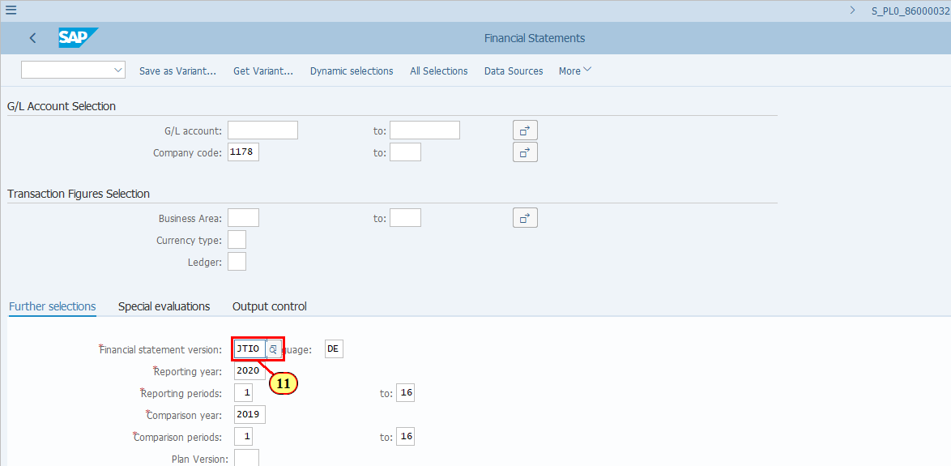
[12] The *Language field is filled out. | 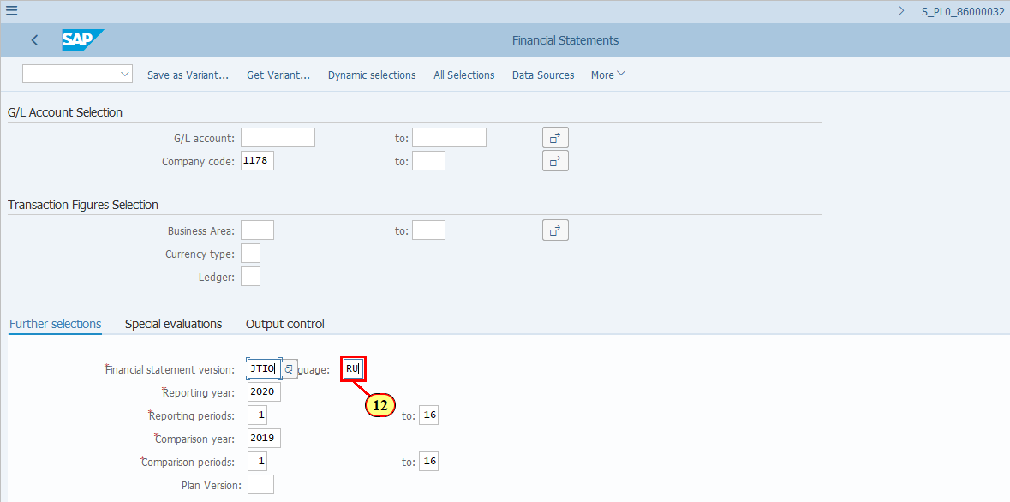
  This report has inherited many similar features of the ECC Financial Statements report such as S_ALR_87012284, one of which allows you to display the account balances in the structure of FSV for 2 sets of Reporting Year/Periods for comparison. | 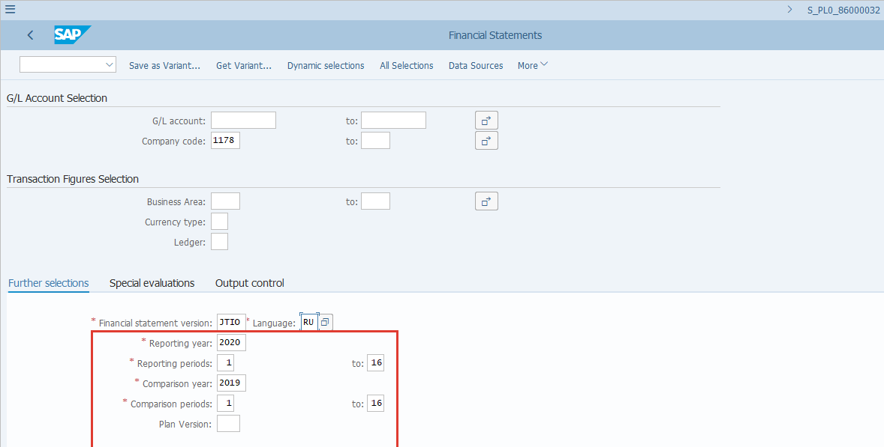
  These are the typical output types of a Financial Statement in SAP.  - Classical List: Select it if you simply want to print out the report as shown. It shows the structure as per FSV but the report is not interactive.  - ALV grid control: Select it if you are considering downloading the report to excel for further analysis. Values are displayed in FSV structure with the possibilities of changing layouts and performing some simple totals/subtotals. etc..  - ALV Tree Control: Interactive design allowing you to see your FSV in a highly structured view, with tree nodes representing Financial Statement Captions that can be expanded to see details at account level and collapsed at summrized levels.  All of these outputs in this report do not allow users to drilldown to line item details.  Click to continue.  [13] Classical list is now selected. | 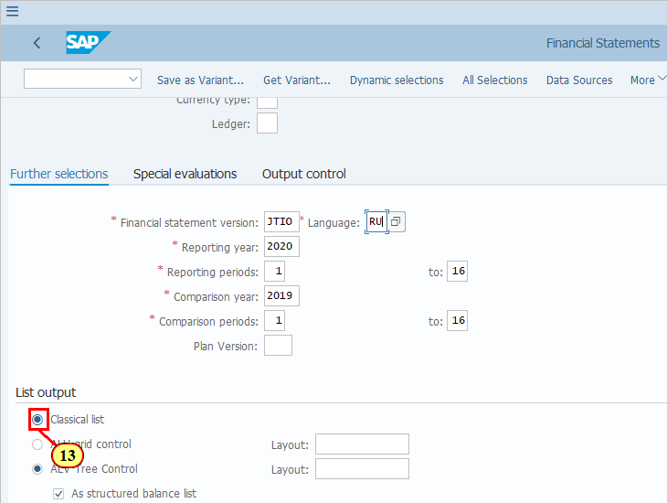
[14] Click Execute .  You can also press F8. | 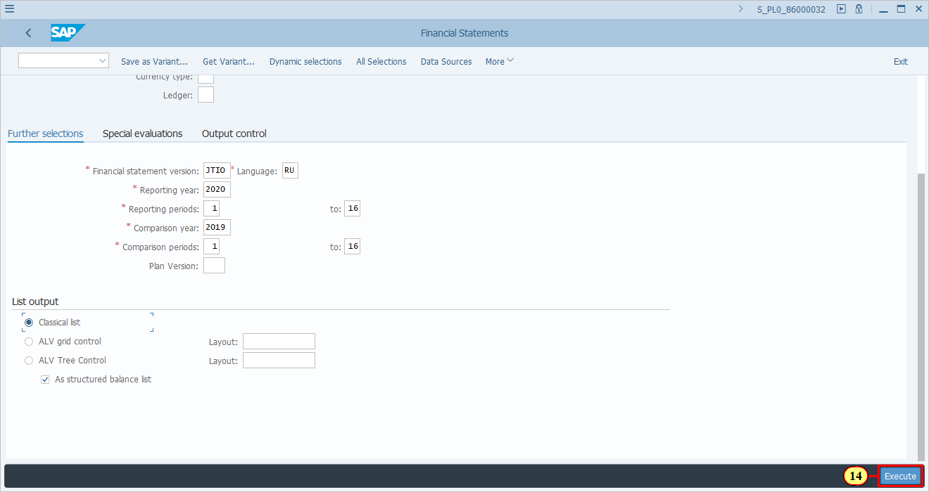
  Features of Classical list from a user's point of view:  - Data is displayed based on selected FSV with details already expanded to account level and no possibility to collapse.  - Total/Subtotal rows are highlighted in yellow. (Refer to the next screenshot)  - No possibility to perform any layout change or add additional subtotal/totals.  By default if you didn't select Ledger and Currency Type, the report is displayed in Company Code currency (LC1) and for Leading Ledger (0L).  Click to continue. | 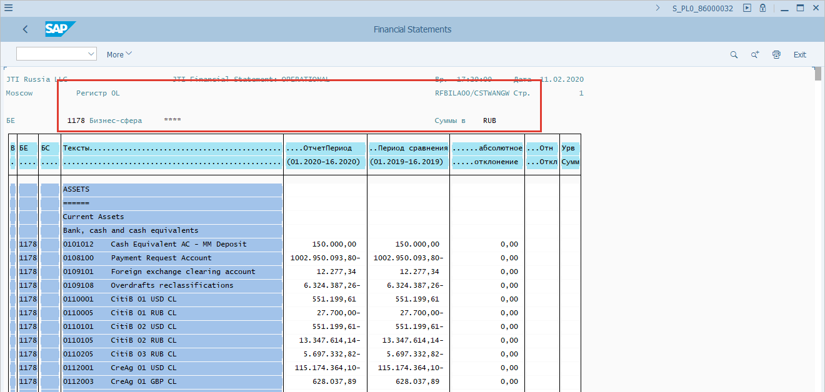
  Rows for Totals are automatically highlighted in yellow. | 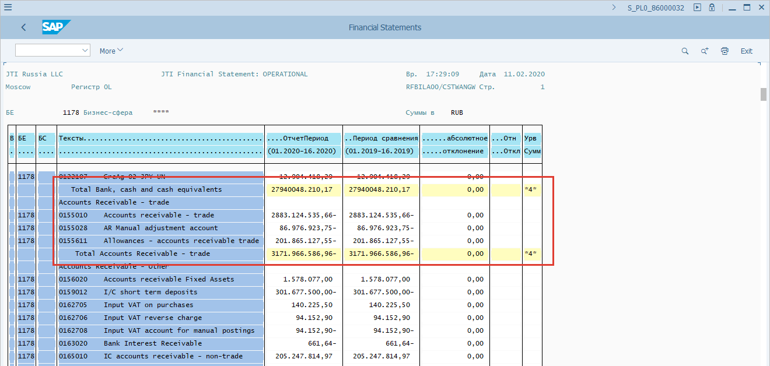
[15] Click Back .  You can also press F3. | 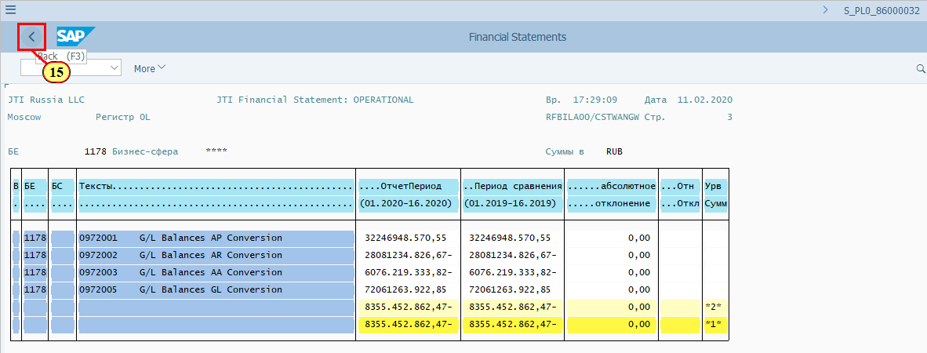
  Now let's specify the Currency Type and Ledger then execute the report again.  [16] The Currency type field is filled out. | 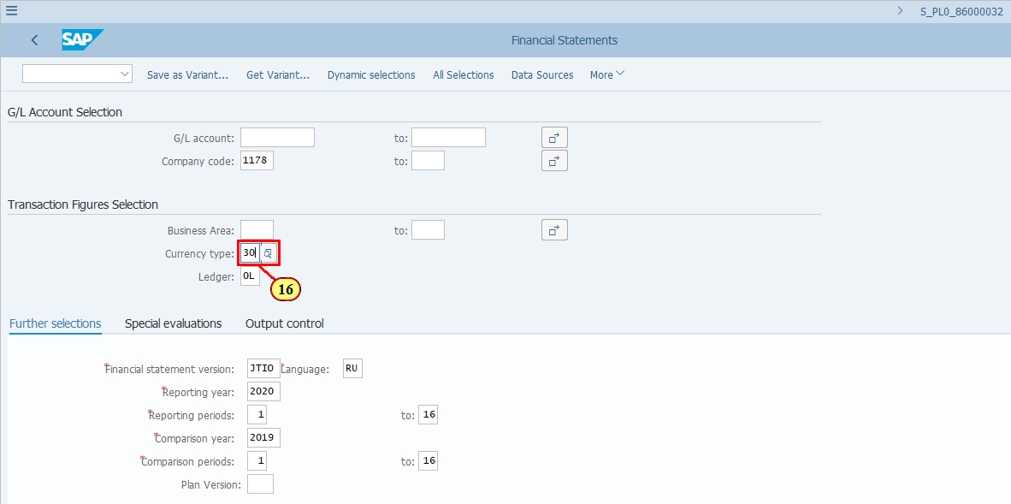
[17] The *Language field is filled out. | 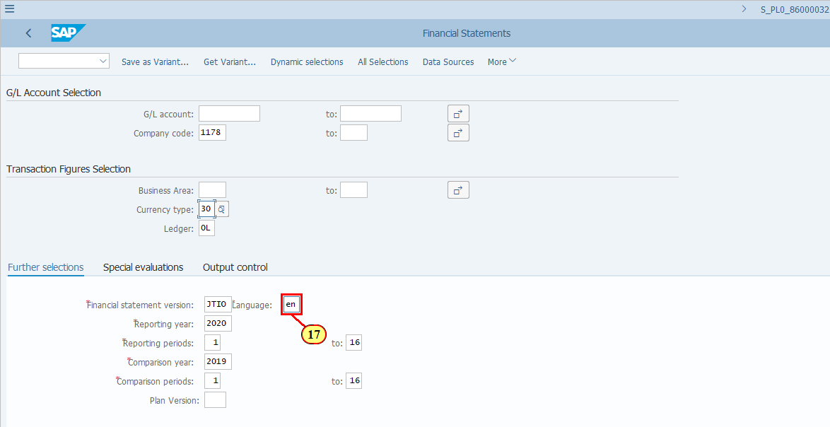
[18] The Ledger field is filled out. | 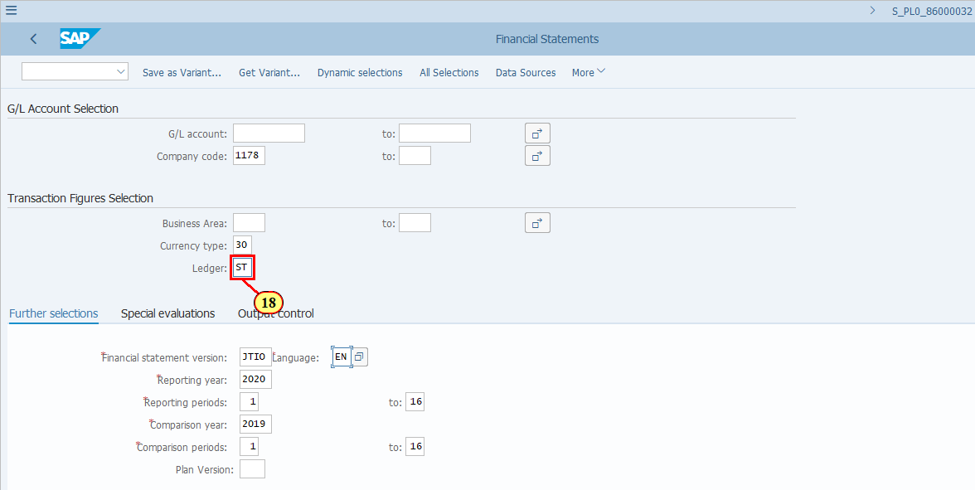
[19] Click Execute .  You can also press F8. | 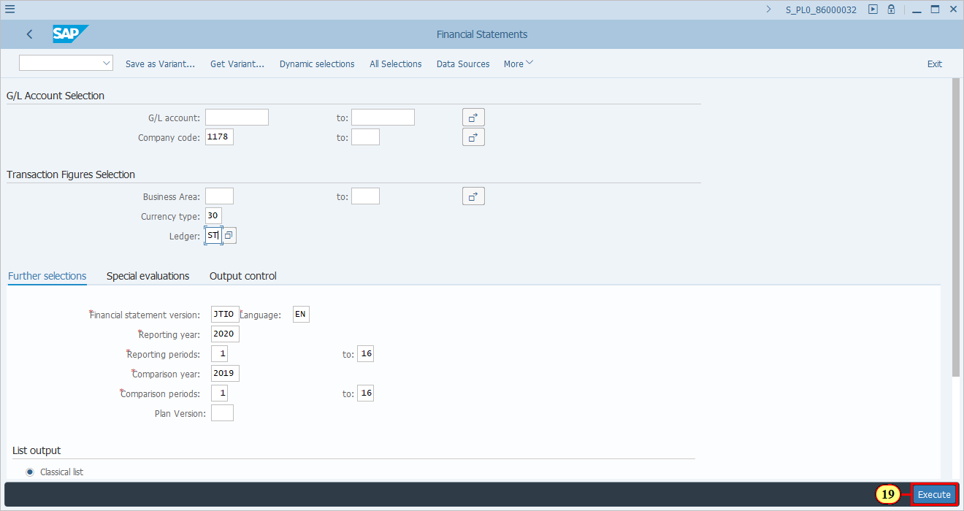
  The report is now displayed with the updated Ledger (ST) and Currency Type (30-LC2-USD). | 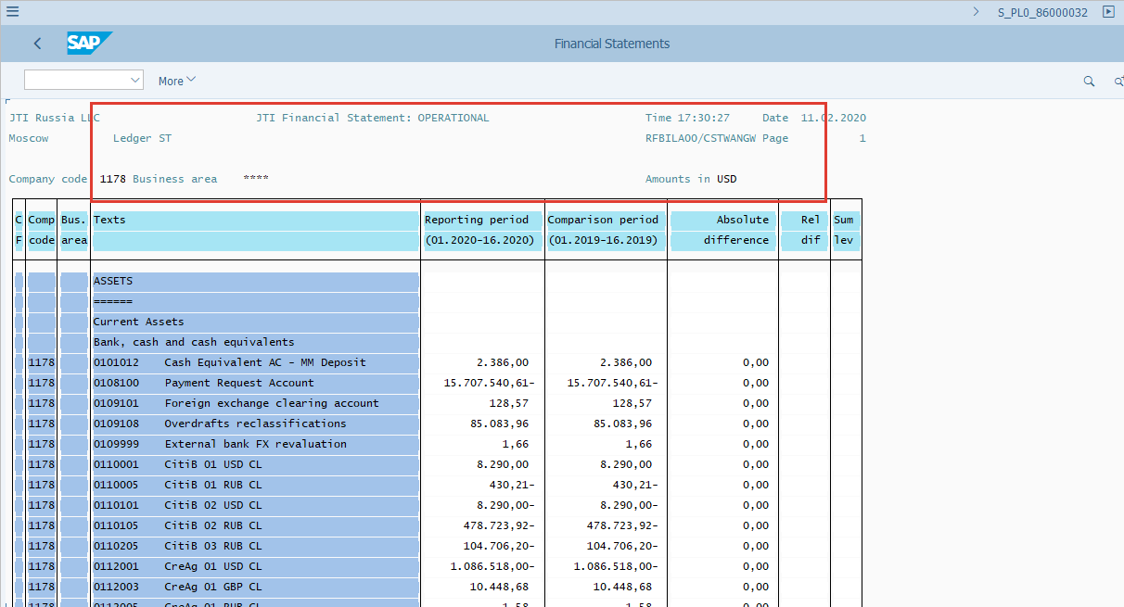
[20] Click More . | 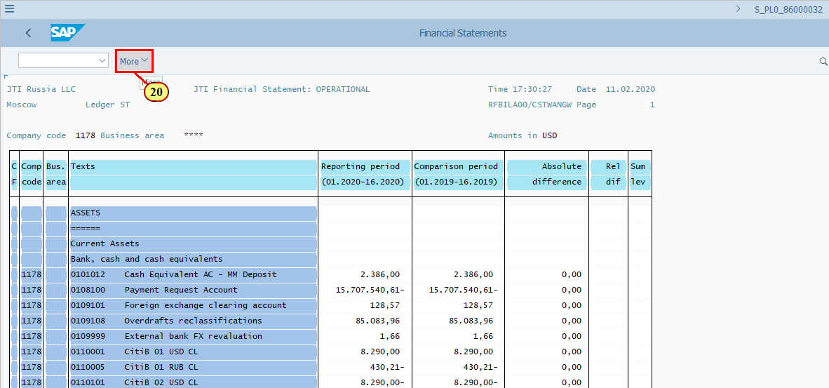
  As explained earlier, there's not much you can do with the report in Classical List format apart from viewing it as shown and print it out. You can print the report as usual and download the report via one of the two "List" functions via the More menu.  [21] Clicking the entry selects it. | 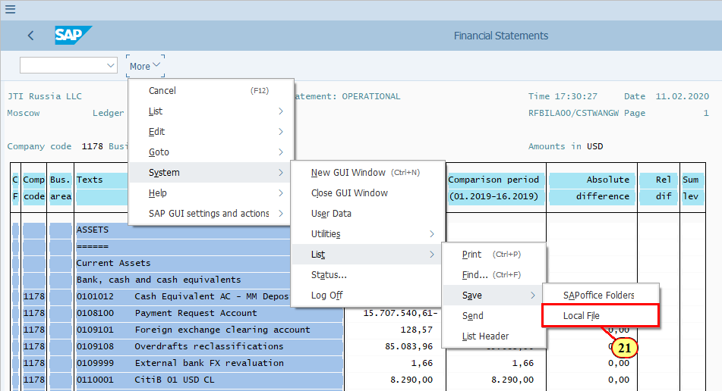
  You may choose any format but the HTML format allows you to download the report to a view which is the sam as what you see on the screen.  You may use other formats together with additional formatting in Excel to receive a download file which you can continue to use for further analysis or reporting.  [22] HTML Format is now selected. | 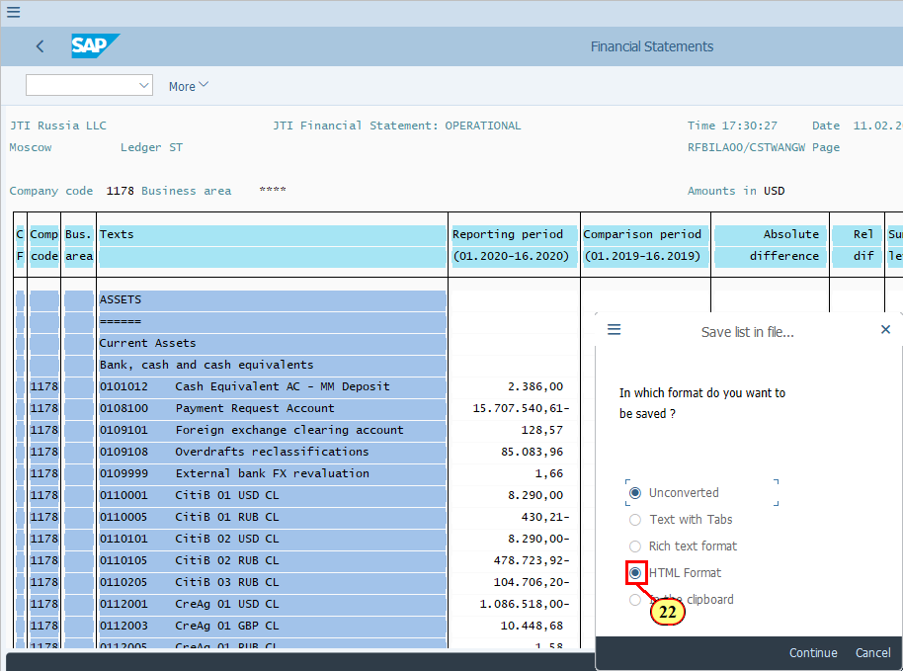
[23] Click Back to exit the report. | 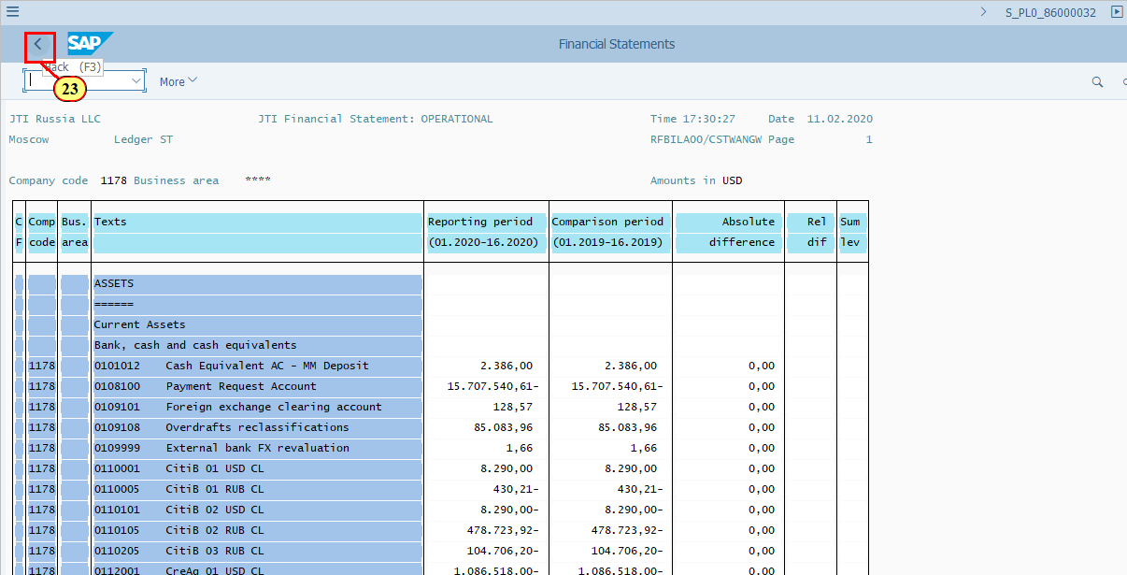
  Let's execute the report with the same selection parameters but in ALV grid control.  [24] ALV grid control is now selected. | 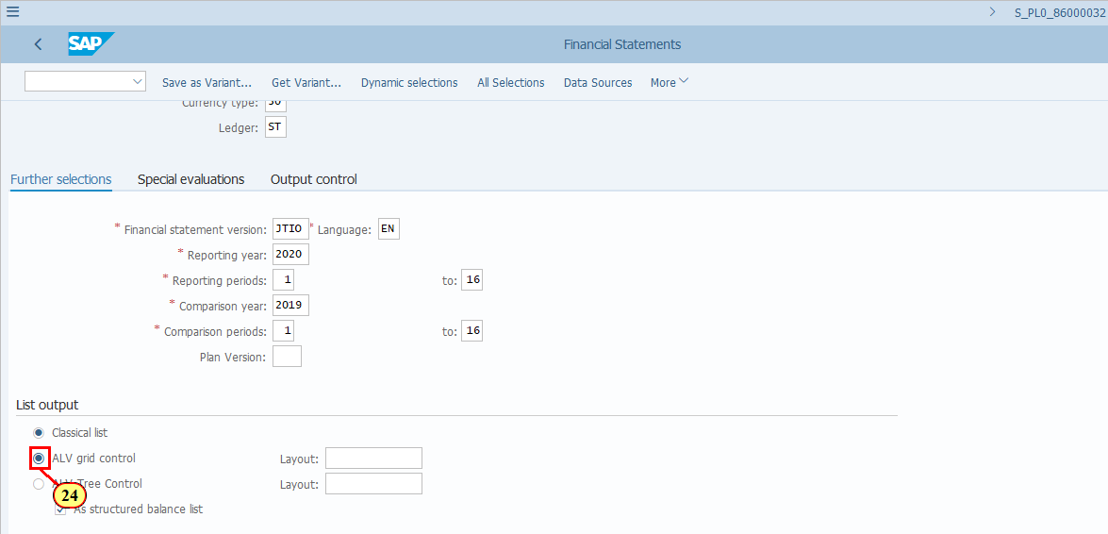
[25] Click Execute .  You can also press F8. | 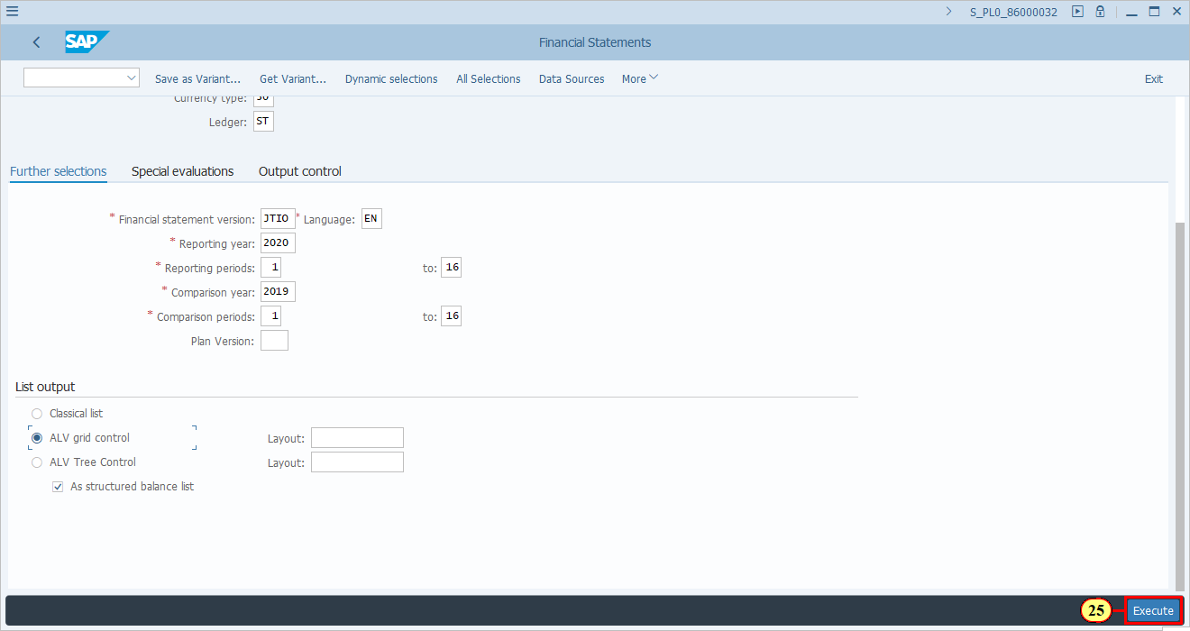
[26] Click Continue .  You can also press Enter. | 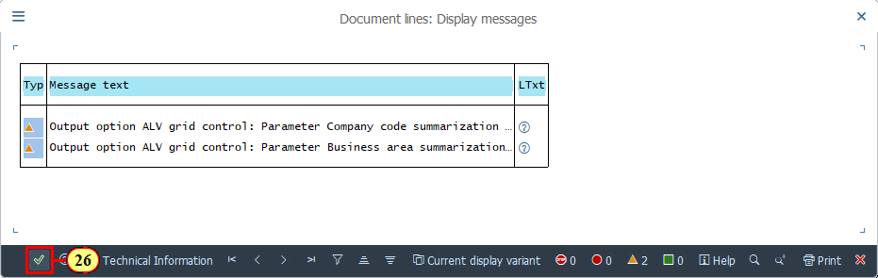
  Features of ALV grid control from a user's point of view:  - Similar to Classical list  - Data is displayed based on selected FSV with details already expanded to account level and no possibility to collapse.  - Total/Subtotal rows are highlighted in yellow.  - Different from Classical list  - Output is in tabular form therefore you can use various functions to simulate the data shown, e.g. sorting, filtering, total/subtotal, change/select/save layouts, etc.  - You can view the list in Excel format, in which you can perform more temporary calculations and analysis  - In addition to downloading the output as a List, you can download it straight to Excel format.  - Drilldown to line item detail is not possible although you see a "Call Report" button on the menu.  Click to continue. | 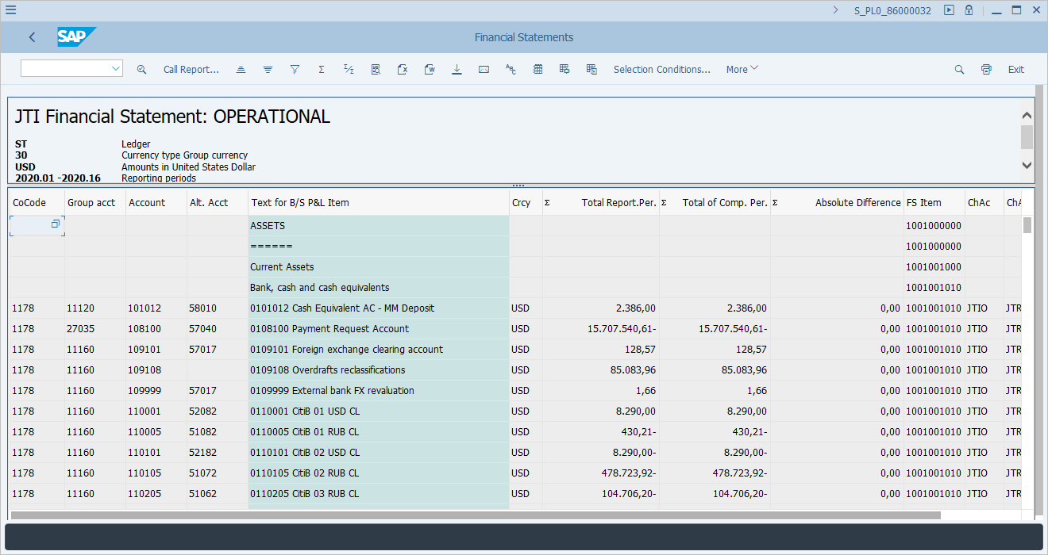
[27] Click Change Layout... .  You can also press Ctrl+F8. | 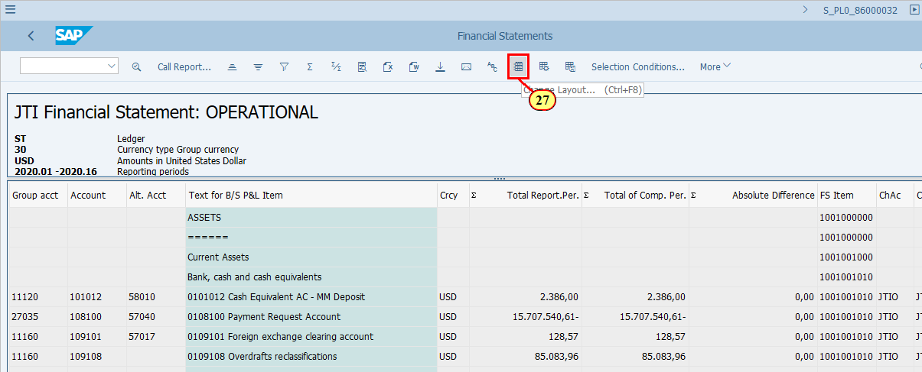
  As you can see, more information can be displayed in ALV grid control. You can choose the fields that you need to show in the report.  [28] Click Cancel .  You can also press F12. | 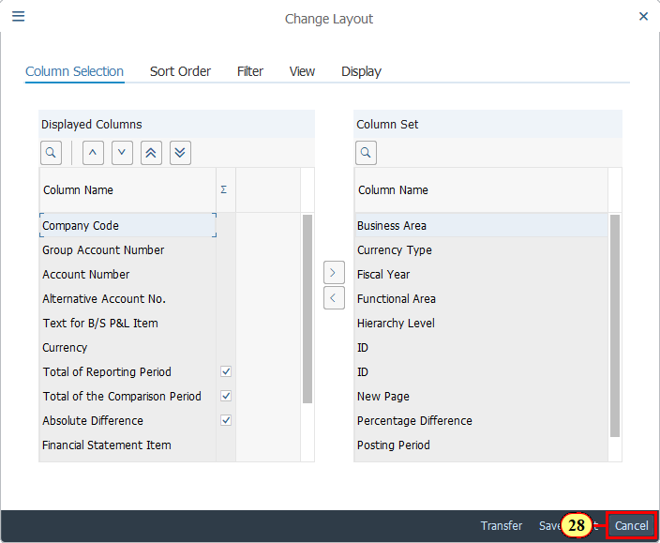
  You may switch the display to Microsoft Excel.  [29] Click Microsoft Excel .  You can also press Ctrl+Shift+F7. | 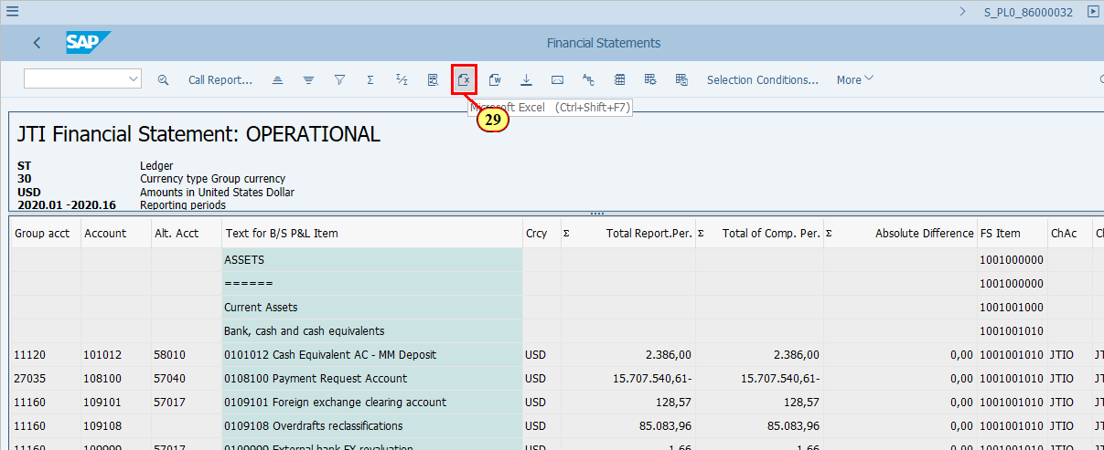
  You can use the basic Excel functions here. You can also save it locally.  [30] Click . | 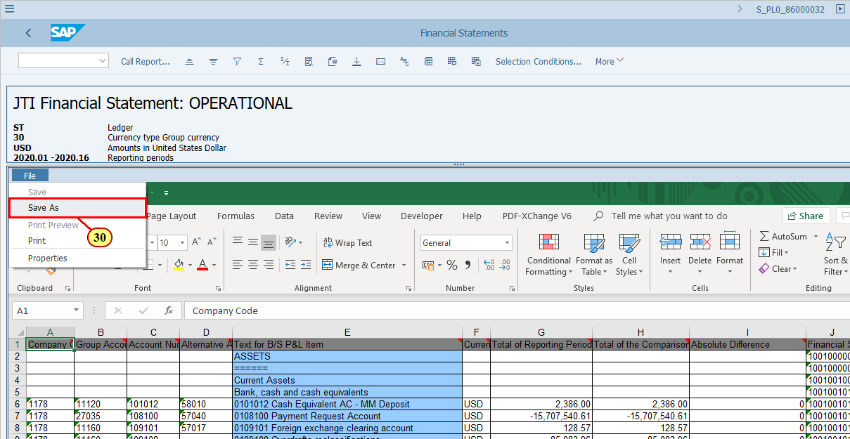
  You may switch the display back to ALV grid.  [31] Click More . | 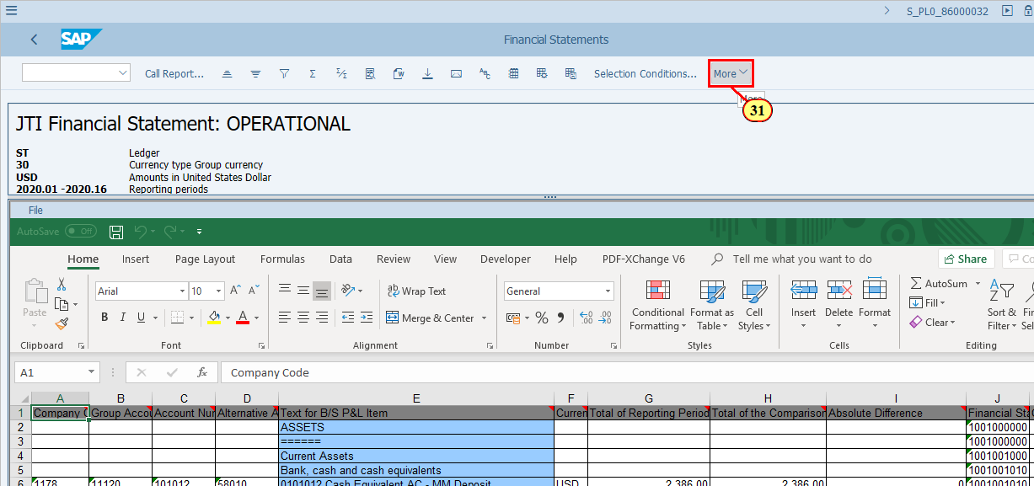
[32] Clicking the SAP List Viewer menu item executes it.  You can also press s. | 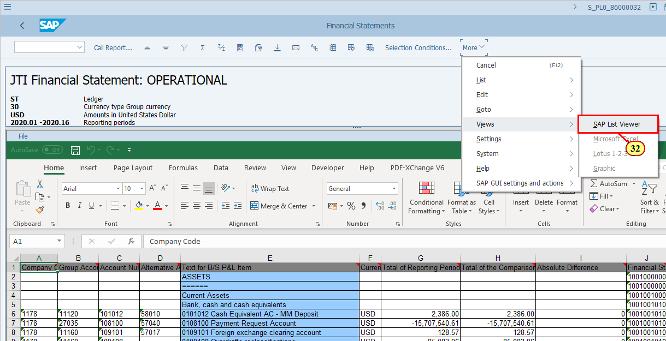
  To download the report to local file, you may use the Local File icon, or follow the More menu,  [33] Click Local File .  You can also press Ctrl+Shift+F9. | 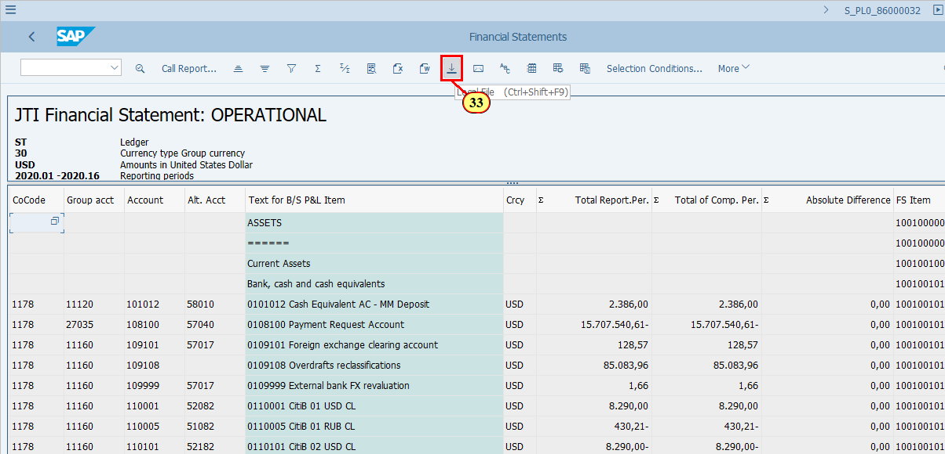
[34] HTML Format is now selected. | 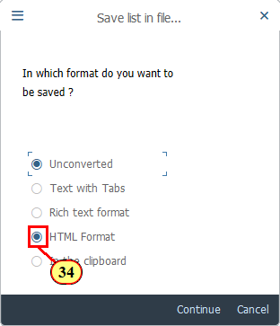
[35] Click More . | 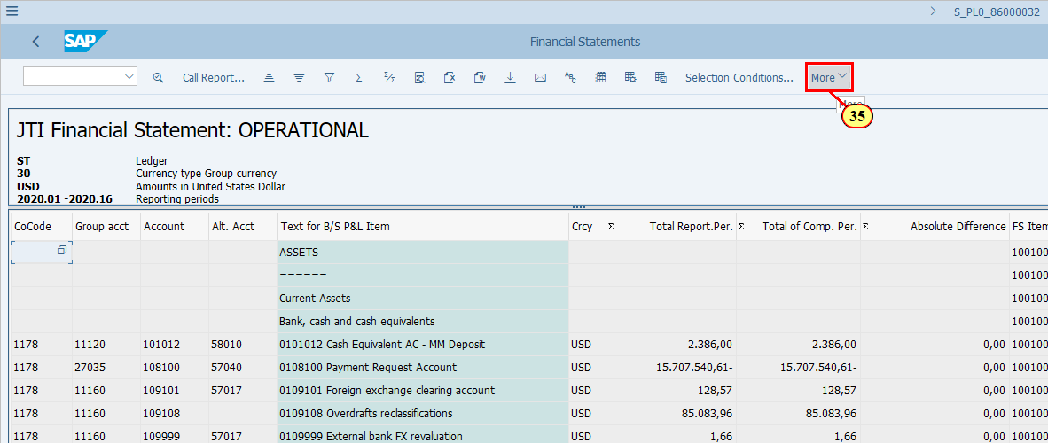
  Choose Spreadsheet if you want to perform further analysis of the data. Choose Local File if you only want to save what you see.  [36] Clicking the Spreadsheet... menu item executes it.  You can also press a. | 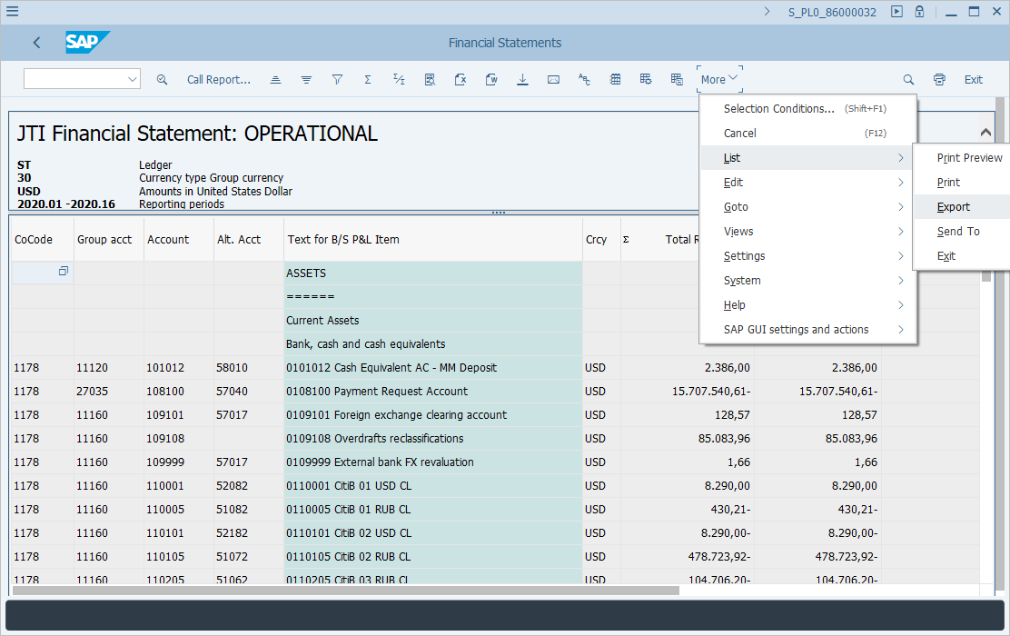
[37] Clicking the button opens a dropdown list. | 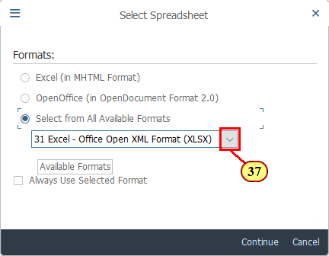
[38] You may choose any format to meet your needs. The recommended format will display the same columns and rows in exactly the same format that you see on the screen.  Clicking the entry 33 Excel - in existing XXL format selects it. | 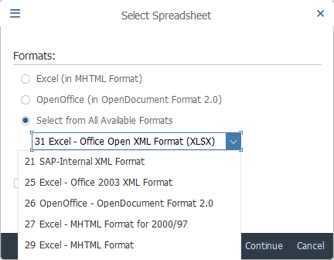
[39] Click Back .  You can also press F3. | 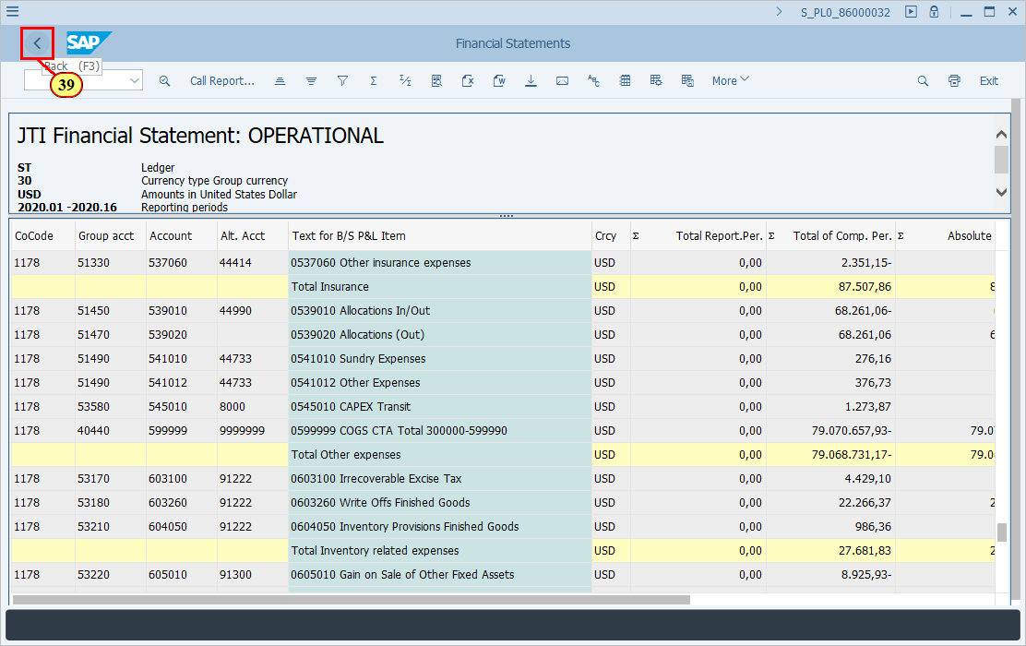
  Let's execute the report with the same selection parameters but in ALV Tree Control.  [40] ALV Tree Control is now selected. | 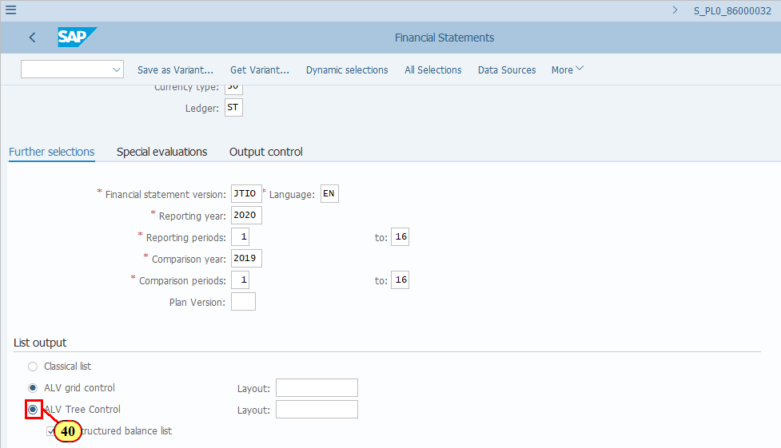
[41] Click Execute .  You can also press F8. | 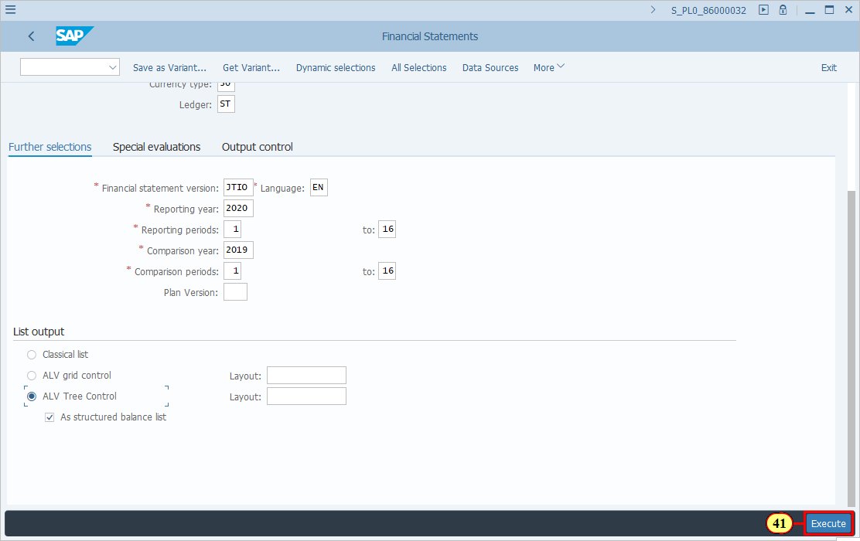
  Features of ALV Tree Control from a user's point of view:  - Similar to Classical list and ALV grid control  - Data is displayed based on selected FSV  - Different from Classical list and ALV grid control  - Output is in a tree format, with nodes representing Financial Satement Captions expandable and collapsable.  - The initial view of the report output shows only the highest level nodes on the Financial Statement Version, such as Assets, Liabilities & Sharehold Equity.  - You can then either expand the full FSV to account level, or expand selected FSV item to account level.  - You do have the possibility to print or download the report, however you cannot download it straight away to Excel format.  Click to continue.    As you can see there are many levels on the FSV hierarchy. You may open them one by one.  [42] Clicking the Open folder icon opens the folder ASSETS. | 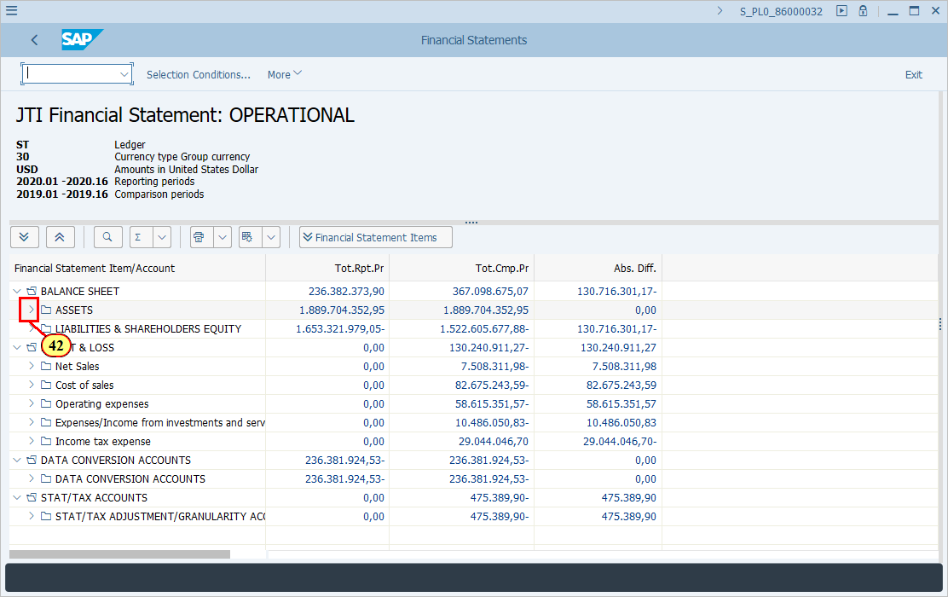
[43] Clicking the Open folder icon opens the folder Current Assets. | 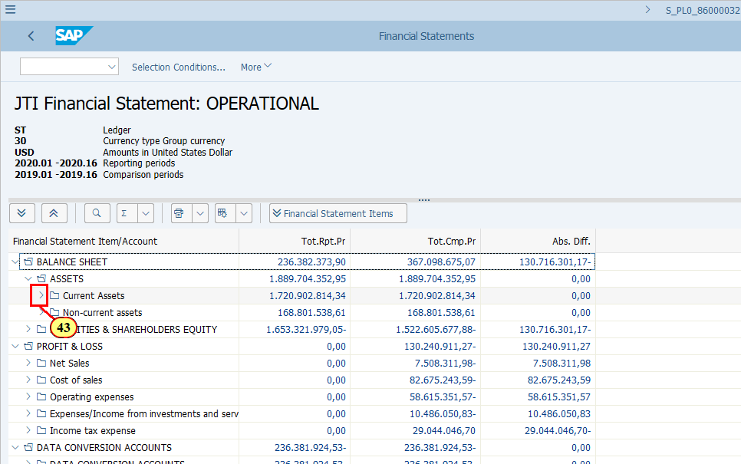
[44] Clicking the Open folder icon opens the folder Cash & Cash Equivalents. | 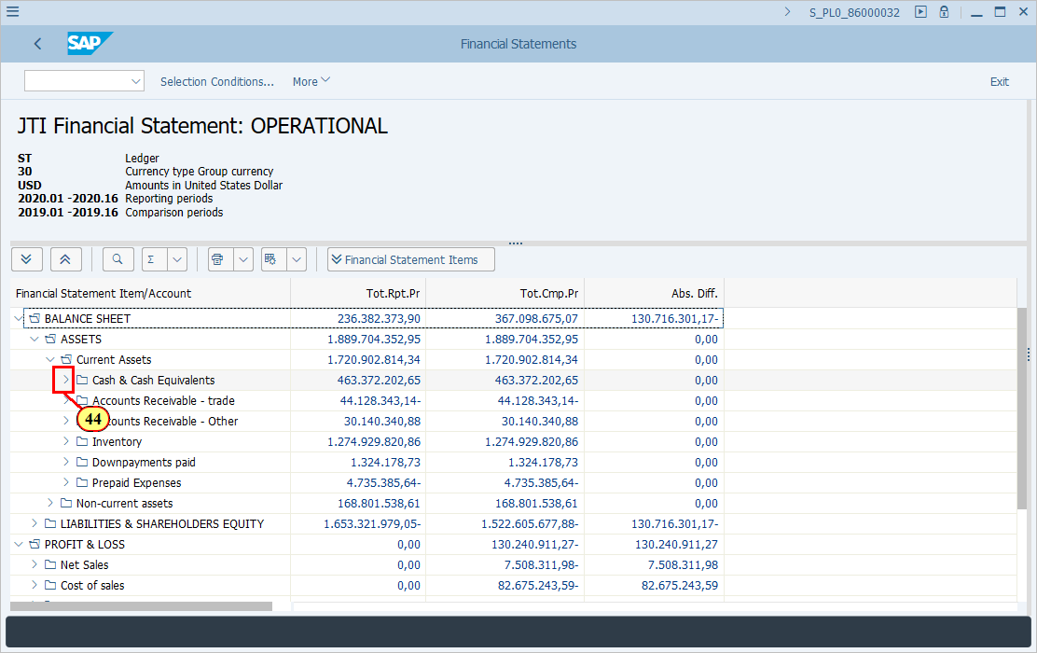
[45] Clicking the Open button opens a dropdown list. Now you are finally at the account level. | 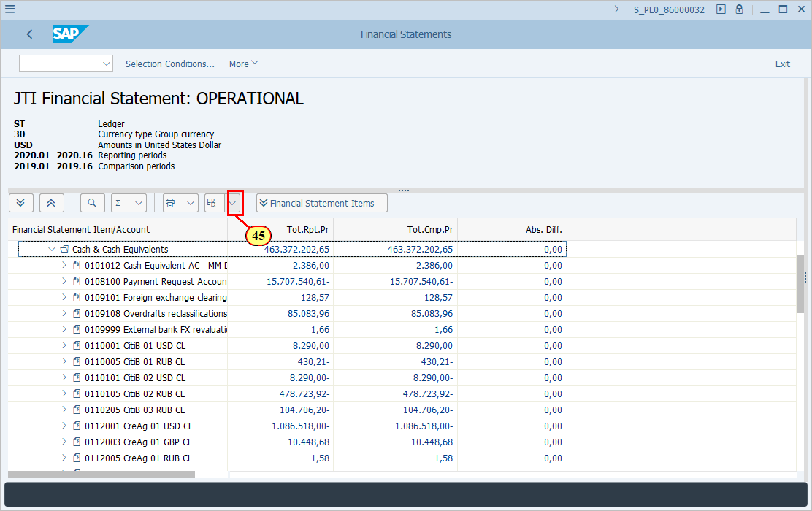
[46] Clicking the Change layout... menu item executes it.  You can also press c. | 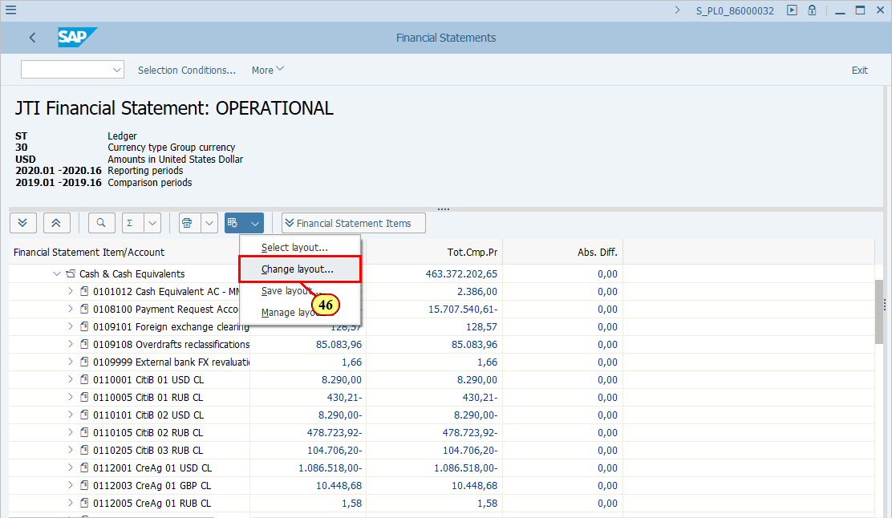
  As you can see there are a couple of additional fields that can be select for display, but this list is far shorter than the list of fields available in the ALV grid control output. | 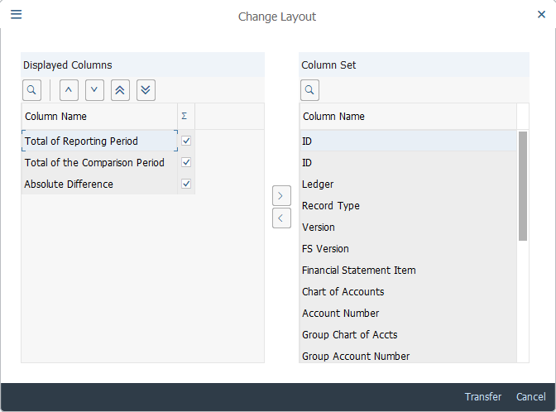
[47] Clicking the 'Close folder' icon closes the folder Cash & Cash Equivalents. | 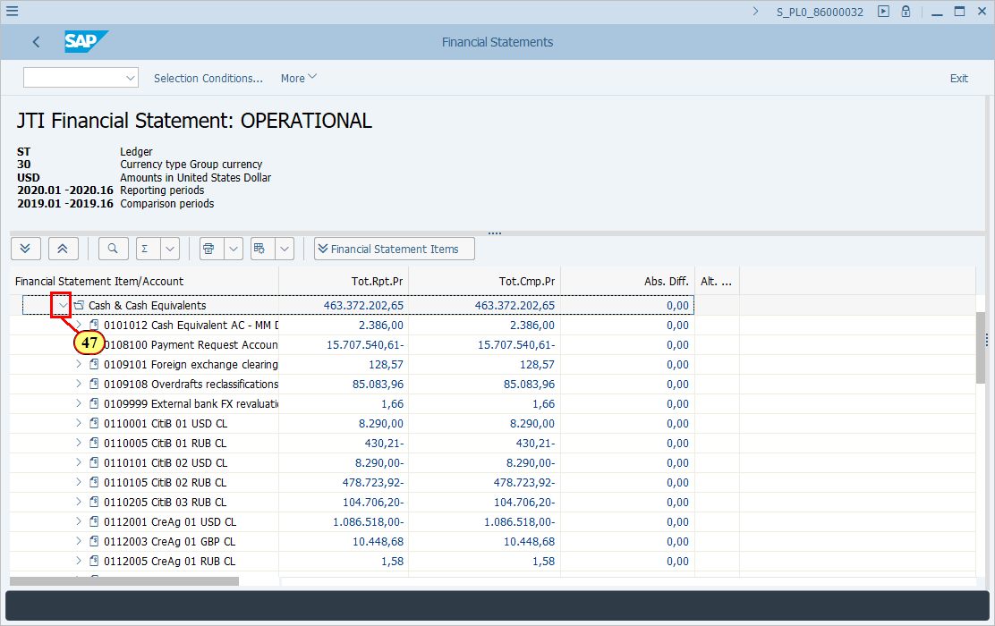
[48] Click BALANCE SHEET . | 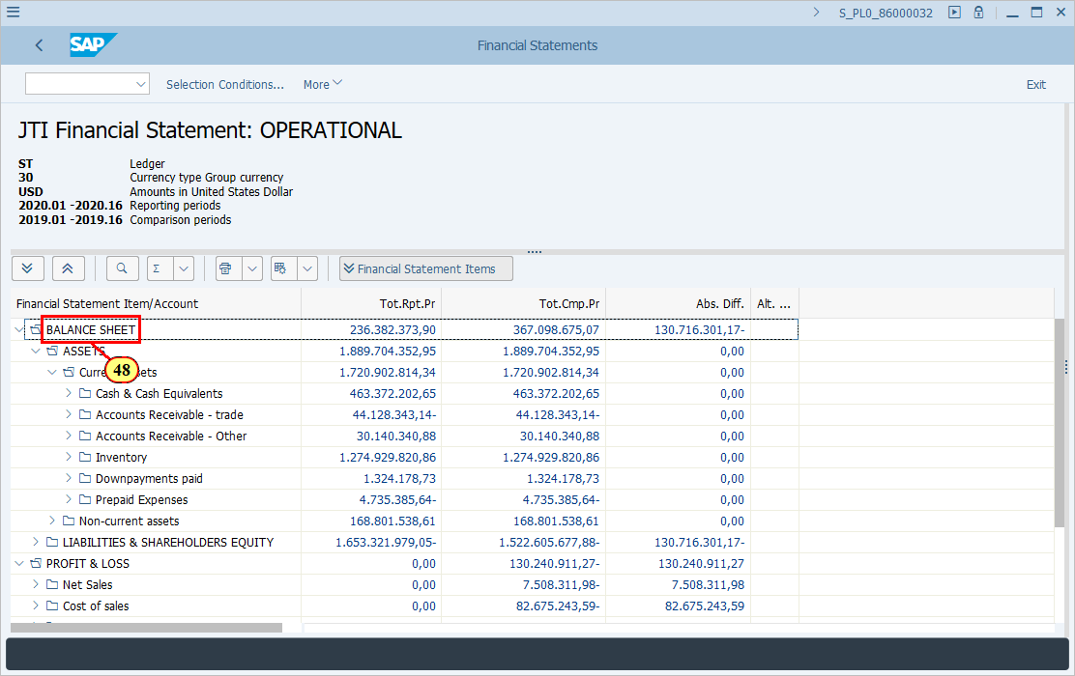
[49] This is the one-step expand button if you wish to expand all the nodes (Financial Statement Captions) to account level.  Click Financial Statement Items . | 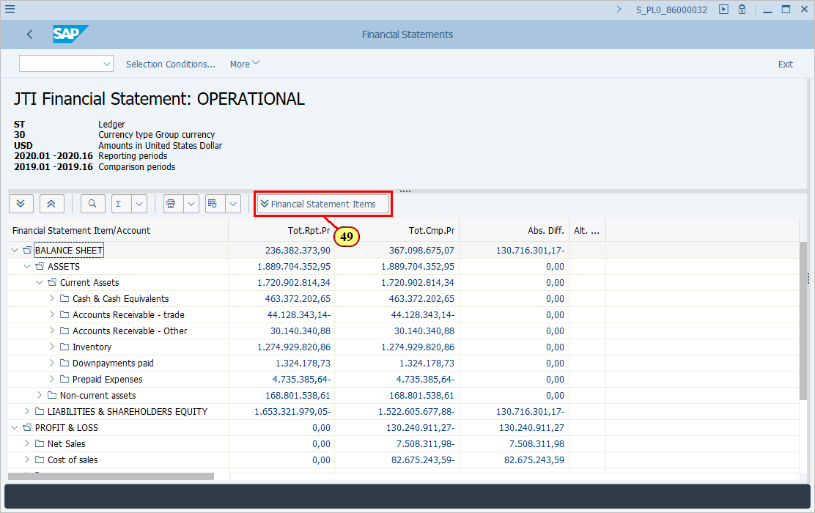
  To print or download the report, you need to click on the Printer icon.  You will have to first print preview the report before you can save it locally. If you find this inconvenient you may want to execute the report using the other two output types.  [50] Click Print . | 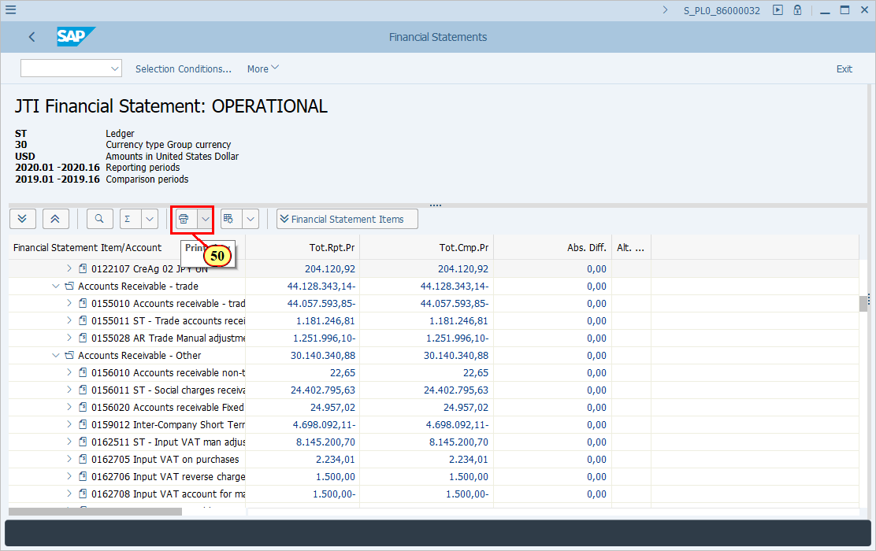
[51] To print the report showing the same level of hierarchies that you see, clicking the Print view .  You can also press p.  If you wish to print the report with the lowest level of the hierarchy, use the next option Print entire hierarchy. | 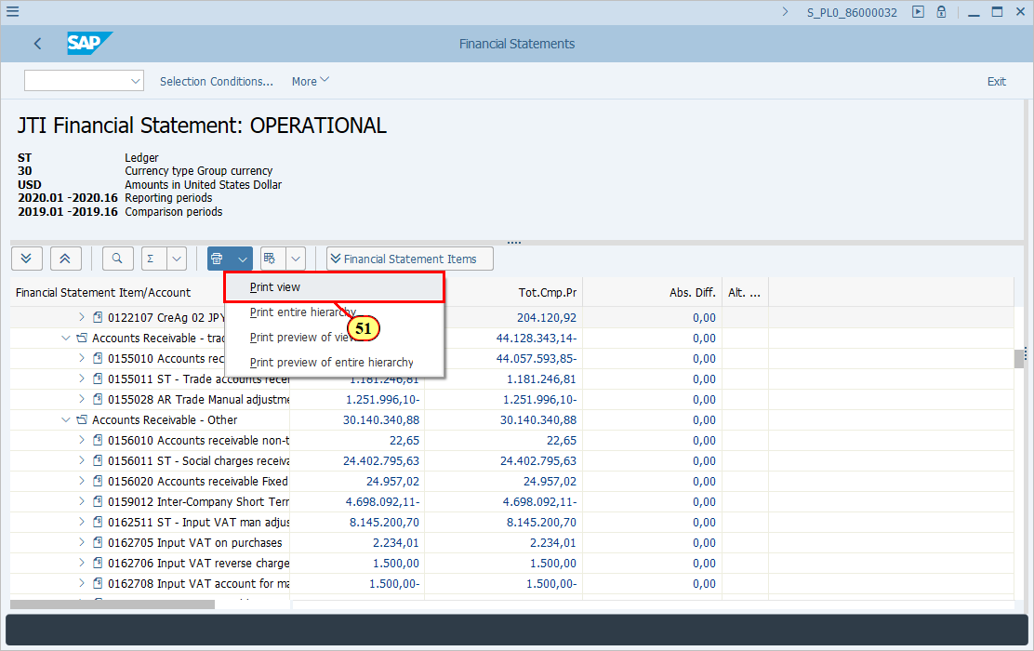
[52] To download the report, first Print Preview.  Clicking the Print preview of view menu item executes it.  You can also press p. | 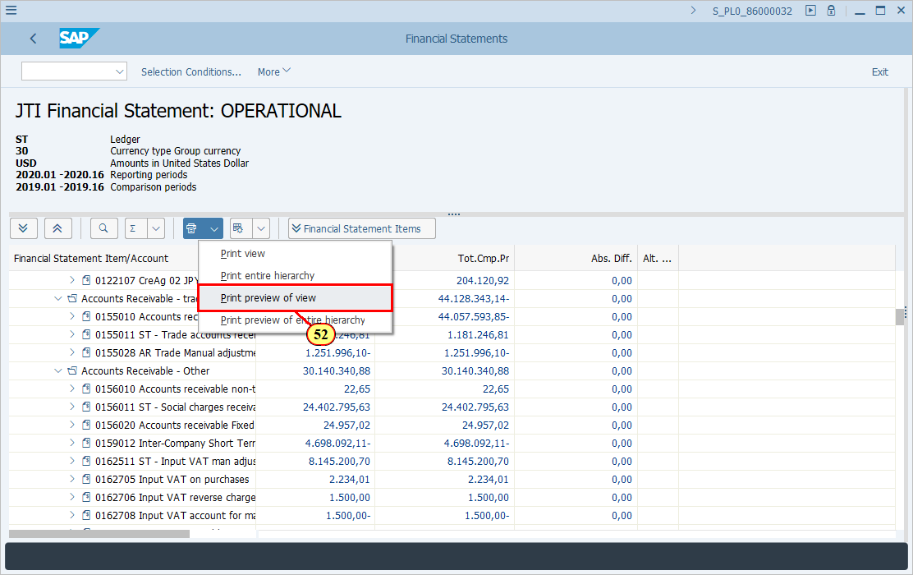
[53] Click More . | 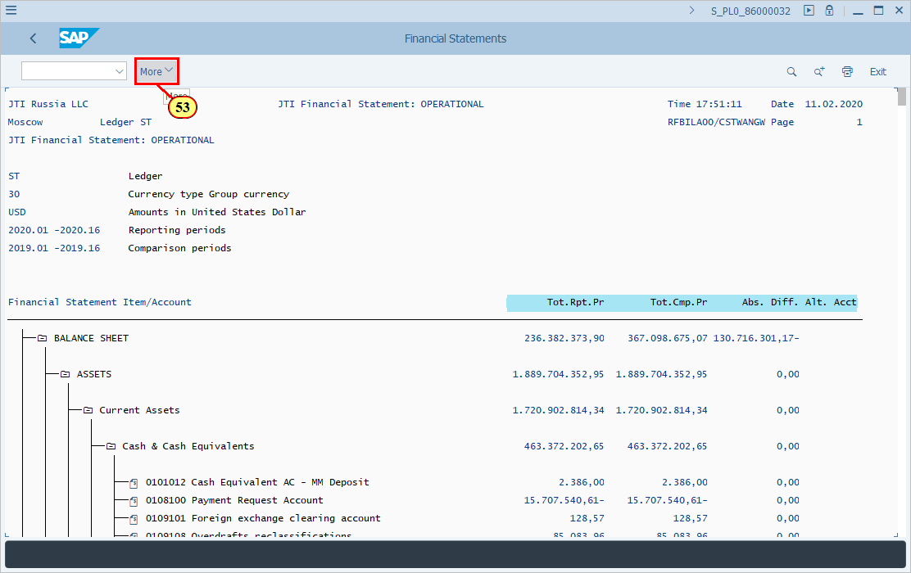
[54] Clicking the Local File menu item executes it.  You can also press i. | 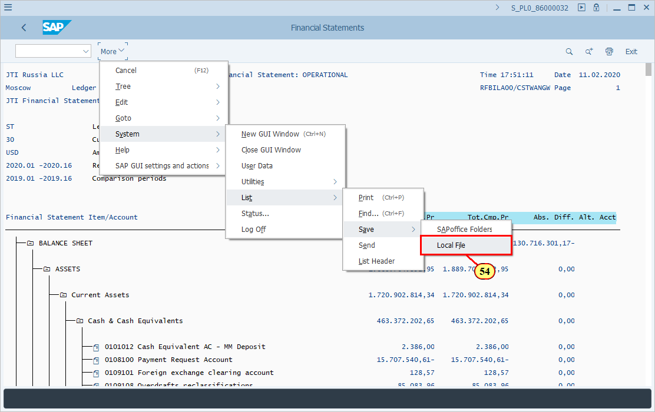
[55] HTML Format is now selected. | 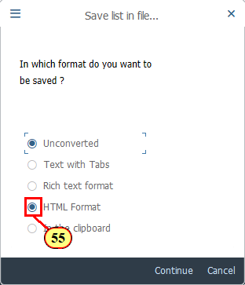
[56] Click Back .  You can also press F3. | 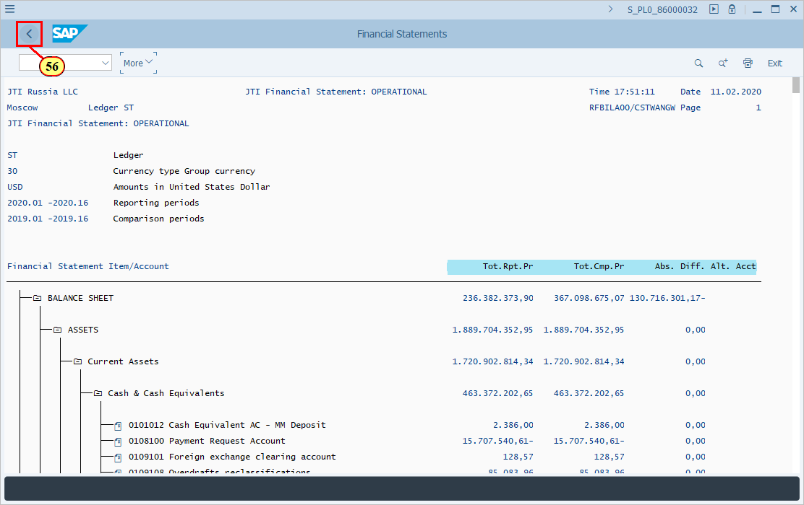
[57] Click Exit .  You can also press Shift+F3. | 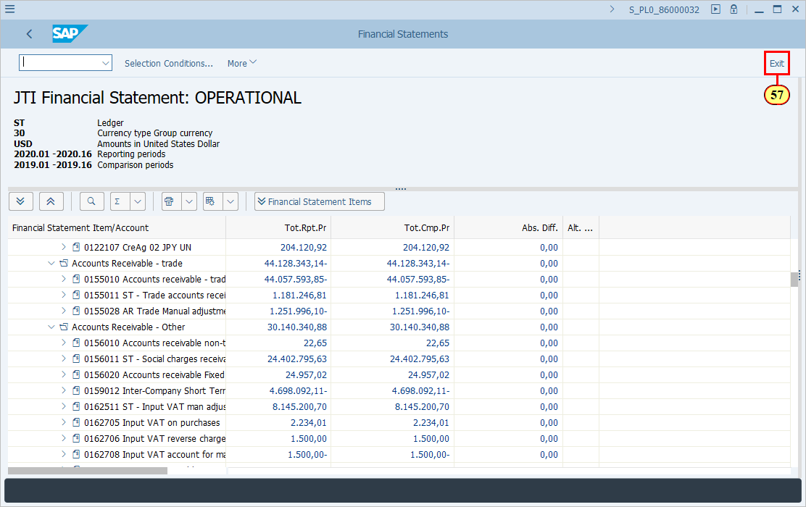
  Now let's take a look at the other two tabs on the selection screen.  You normally do not need to change any default settings in the other two tabs however it is important you understand what each of them is responsible for.  [58] Clicking the Special evaluations tab selects it. | 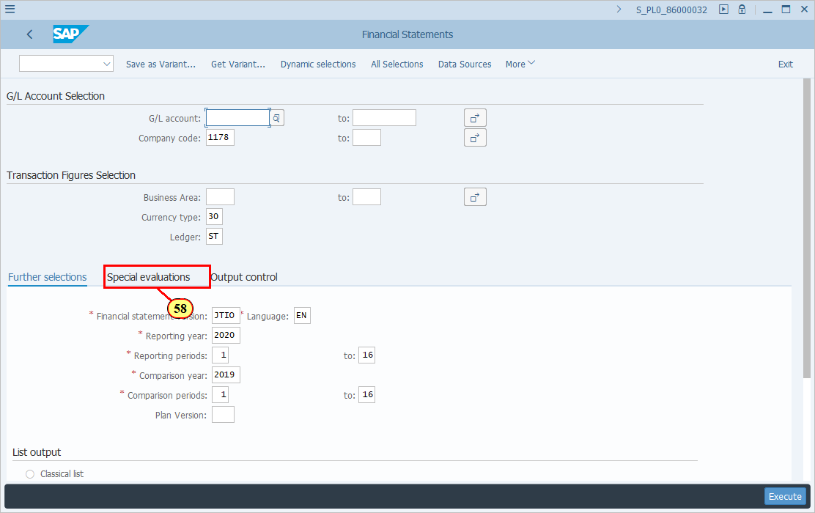
  Balance sheet type determines what balances/movements of the accounts that the report will display. The default selection is 1. This means for Balance Sheet accounts, the cumulative balances will be displayed and for P&L accounts the year to date balance will be displayed.  If you need to show account balances differently, you may explore the other available options. | 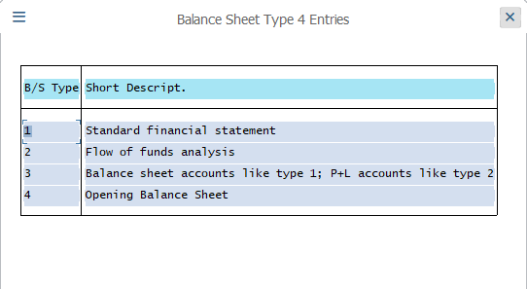
  Alternative account number should be selected if you execute this report using a Financial Statement Version (FSV) which is compiled based on Alternative account numbers.  If you do not know whether your selectd FSV is based on JTIO or Alternative account numbers, you should speak to your Power User or R2R Competency Center. GSD/BTS can also help you to check it out from technical point of view. | 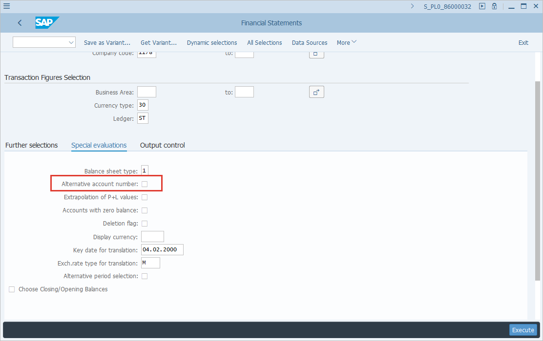
  Accounts with zero balance should be selected if you wish to display the full FSV items and details regardless of whether some items have zero balances.  Normally this indicator does not need to be selected however you should bear in mind that only FSV items with any balance will be shown if you do not have this indicator ticked. | 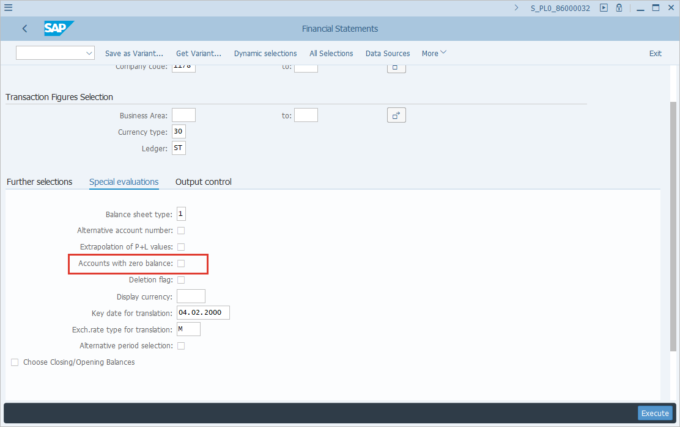
  Display currency / key date for translation / Exch.rate type for translation  These fields are normally not used unless you specifically want to simulate the values displayed in the report using your selected currency. | 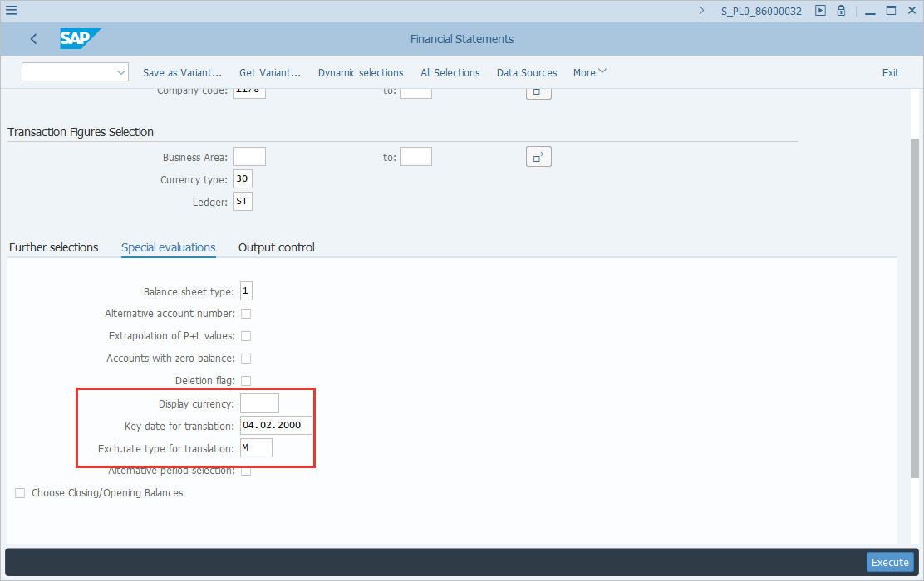
[59] Clicking the Output control tab selects it. | 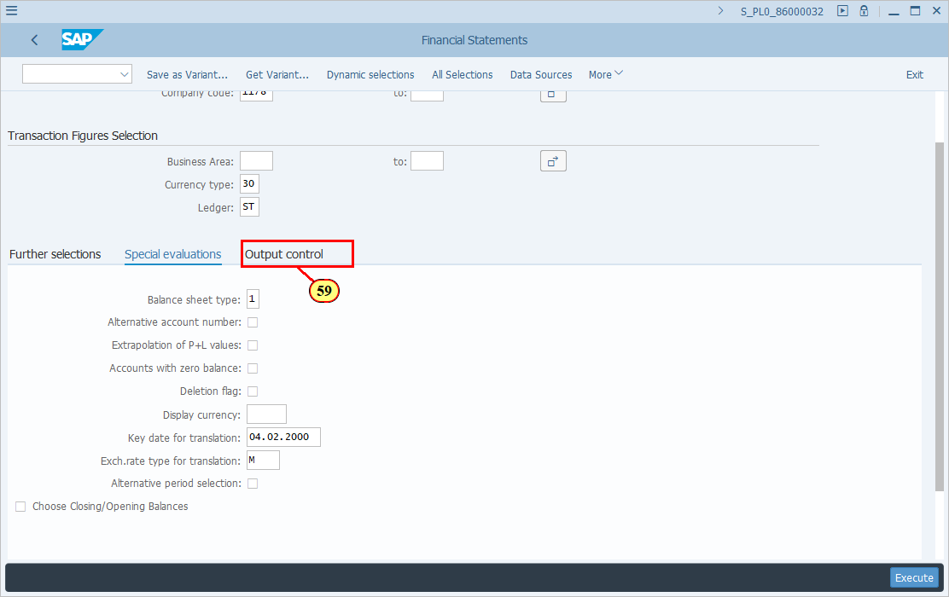
  These two fields should be left with the default value.  Please note that JTI does not use Business Area field at all but as these are mandatory fields you have to put a value there. | 